Retinal Disease Classification based on Optical Coherence Tomography images using InceptionV3Net Architecture

ABSTRACT
Retinal diseases such as Age-related Macular Degeneration (AMD), Diabetic Macular Edema (DME), and Choroidal Neovascularization (CNV) are among the top reasons for vision impairment worldwide. Optical Coherence Tomography (OCT) imaging is commonly employed in the early diagnosis and classification of numerous retinal diseases. In this study, we propose a deep learning-based approach utilizing the InceptionV3 architecture for the classification of retinal diseases using retinal OCT images. The dataset used includes labeled OCT scans belonging to four classes: CNV, DME, DRUSEN, and NORMAL. Due to class imbalance, class weights and data augmentation were employed to improve model generalization. InceptionV3 model was fine-tuned with pre-trained ImageNet weights, and an additional flatten and dense layer was added for classification. The model was trained and evaluated using accuracy, precision, recall, area under the curve (AUC), and confusion matrices. Experimental results demonstrated that the model achieved a test accuracy of 89.67%, with an AUC of 0.9819, demonstrating its efficiency in differentiating between the different retinal conditions. Despite strong classification performance for CNV and Normal classes, challenges remain in classifying Drusen due to high intra-class variance and feature similarities with other conditions. Overall, the results from this study highlight the potential of deep learning models in assisting ophthalmologists with automated retinal disease diagnosis, ultimately improving early detection and treatment outcomes.

INTRODUCTION

Age-related macular degeneration (AMD), a multifactorial disease, is one of the leading causes of blindness in the world. It highly affects individuals over the age of 65 and is responsible for about 8.7% of cases of vision-loss [1]. AMD is associated with the damage of the macula, the region responsible for high-acuity vision, and hence may lead to the gradual impairment of the central visual field. The severity of AMD depends on various genetic and environmental factors and can be categorized into dry and wet. Dry cases involve yellow or white deposition of cellular debris, referred to as drusen, and these cases account for 90% of all AMD cases. The other 10% comprises cases of wet AMD where due to growth or leakage of blood and fluid into your retina the visual field is compromised. Despite being in a lesser percentage, cases of wet AMD are likely to be more severe [2]. Choroidal neovascularization (CNV) is a condition that causes abnormal blood vessel growth in the choroid layer of the eye. All wet AMD cases involve CNV, but not all CNV cases are due to wet AMD. CNV is a common cause and a hallmark of wet AMD [3][4]. It also leads to a rapid decline in central vision. Additional symptoms may include visual distortion in color and metamorphopsia, a condition where objects are misshapen [5].
Another leading cause of loss of vision is diabetic macular edema (DME). High blood sugar levels from diabetes cause vessels to swell up and consequently leak into the retina and the central macular region [6]. DME is the primary cause of vision loss in both proliferative and non-proliferative diabetic retinopathy. The occurrence of DME varies significantly, affecting between 4.2% and 14.3% of individuals with type-1 diabetes mellitus and between 1.4% and 5.57% of those with type-2 diabetes mellitus [7].

Fig 1: Types of Retinal Diseases

Optical Coherence Tomography is a non-invasive imaging technique for visualizing cross-sectional images [8]. It combines the coherent backscattered light from a sample and from a reference. This is also referred to as an interferometric imaging modality [9]. OCT systems have gained wide popularity among the ophthalmology departments of various hospitals as a consequence of inadequate diagnostic tools for depth information of the retina [8]. OCT enables the ophthalmologist to see the retina’s layers and visualize its various components such as the optic nerve fibers [11]. It is often preferred over other imaging modalities such as Magnetic Resonance Imaging (MRI), Computed Tomography (CT), and Ultrasonography (USG) due to its fast scanning rates, quick processing modules for image visualization and higher resolution (typically of 20-5 µm) [8]. The identification and classification of retinal diseases is carried out on the basis of deformation observed on the retina associated with the disease. The resource demands for these diagnostic tasks are high, especially in underdeveloped areas and countries where population is high and resources are not easily accessible. This could lead to severe health complications for the affected population and if not treated medically, could significantly reduce quality of life. In India, the doctor to patient ratio is still low despite existing hospitals and clinics. Community outreach programs fail due to the lack of trained personnel required for effectively carrying out tests [13].

A computerized method for an efficient medical decision support system could ease the challenges of the clinicians as well as increase accessibility to resources for those in need [14]. Due to recent advancements in technology and image acquisition and processing, these decision support systems can help automate the process of disease detection. This would be subject to change and confirmation by the doctor. These models excel in identifying and extracting features associated with a particular retinal disease from the input image. Many deep learning models and architectures can automatically extract various required features from the training dataset and map them to known classes to finally detect the disease [15].

In the past few years, various Machine learning (ML) models were developed for the recognition of OCT retinal images on subjects with eye disorders such as AMD, diabetic retinopathy, central serous chorioretinopathy, and glaucoma [16]. Among the ML classifiers, the support vector machines (SVM) were seen to perform excellently [17]. These models were mainly used for the automatic detection and quantification of molecules and compounds that were found in the retina that could indicate an abnormal process or a condition [18]. Various Convolutional Neural Network (CNN) architectures have been designed previously to classify these diseases based on various features extracted from the image. CNNs have proved to be the most efficient technique to extract features from the OCT dataset [17]. Deep learning algorithms were found to have more accuracy for classification problems but this comes with the cost of requiring large amounts of data and time for training [16]. A machine learning technique called transfer learning is generally employed to overcome the shortcomings of using traditional deep networks. In transfer learning, pretrained models are used, and works well for OCT images and situations where data is limited. This allows the model to learn faster, enhance its performance, and reduce overfitting [10][12].

Inception V3 is a CNN architecture that is widely used for image classification. It is an upgraded version of the Inception V1, which was introduced as GoogLeNet. It has 42 layers with lesser error percentages, excellent accuracy, and less computational cost than its previous versions. The major modifications that made it significantly better than its predecessors are: factorization into smaller convolutional operations, spatial factorization into asymmetric convolutions, utilizing auxiliary classifiers, and efficiently reducing grid size [19].

Table 1: Summary of Some Relevant Machine Learning Models for Retinal Disease Classification
Authors | Diseases | OCT Scan | Classifier | Train | Validation | Test | Accuracy | Sensitivity | Specificity | AUC | F1 Score
Udayaraju et al., (2023) | DME | 112 | SVM | 70% | NA | 42% | 98.37 | NA | NA | NA | NA
Schwartz et al., (2022) | DRUSEN | 1276 | 3D Inception V1 | 60% | 20% | 20% | 98.4 | 97.8 | 99 | 0.99 | NA
Errabih et al., (2022) | CNV, DRUSEN, DME | 84483 | InceptionV3, VGG16 | 80% | NA | 20% | VGG16: 93.12 Inception: 91.37 | VGG16: DME: 89, drusen: 92, CNV: 100 | NA | NA | VGG16: DME: 90, drusen: 94, CNV: 98
Li et al., (2019) | CNV, DRUSEN, DME | 207130 | VGG16 | NA | NA | NA | DME: 98.8, drusen: 99.2, CNV: 100 | DME: 98.8, drusen: 98.4, CNV: 100 | DME: 98.8, drusen: 100, CNV: 100 | DME:0.9989, drusen: 0.9999, CNV:1 | NA
Ibrahim et al., (2020) | CNV, DRUSEN, DME | 207130 | VGG16 | NA | NA | NA | DME: 100, drusen: 99.79, CNV:100 | DME: 100, drusen: 99.6, CNV: 100 | DME: 100, drusen: 100, CNV: 100 | NA | NA
Vidal et al., (2023) | DME | 419 | VGG19 | 70% | NA | 30% | Original: 94.17, Synthetic: 92.5 | Original: 95, Synthetic: 91.67 | Original: 93.33, Synthetic: 93.33 | NA | NA
Choudhary et al., (2023) | CNV, DRUSEN, DME | 84568 | VGG19 | 83484 | 32 | 968 | 99.17 | 99 | 99.5 | 0.9997 | NA

The numerous works on machine learning models for the classification of retinal diseases using OCT scans are compiled in Table 1. AUC, F1 scores, accuracy, sensitivity, specificity, classifiers (SVM, Inception, VGG16, VGG19), authors, diseases examined (CNV, DME, and Drusen), dataset sizes, training proportions, and more are included as basis for comparison. Depending on the dataset and classifier, the models attain high accuracy (up to 100%) and variable sensitivity/specificity. Commonly used VGG16 and VGG19 perform better when synthetic data is used. Developments in deep learning applications for the identification of retinal diseases are highlighted in the table, too [12].

METHODOLOGY
- DATASET
The dataset considered in the study, titled Large Dataset of Labeled Optical Coherence Tomography (OCT) and Chest X-Ray Images by Kermany, D. S. et al (2018), is a comprehensive collection of medical images designed for research purposes. The dataset includes thousands of validated OCT images used for diagnosing retinal diseases. The OCT images are categorized into four directories: CNV, DME, DRUSEN, and NORMAL. The data is structured into training and testing sets based on independent patients, with each image labeled with its disease type, a randomized patient ID, and an image number [19].

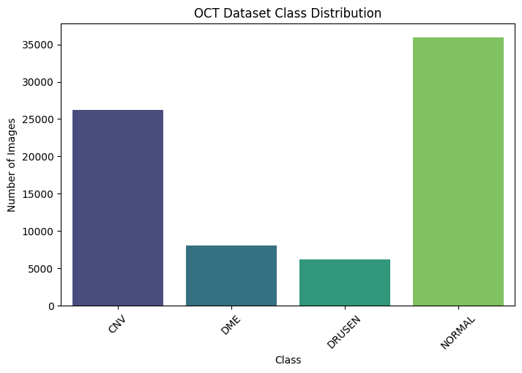
Fig 2: Dataset Distribution
This dataset faces a class imbalance problem. This often arises because the number of images that represent different retinal conditions are significantly unequal. Retinal images under the class Normal have abundance images while that of DME has lesser. Fig. 2 shows the class-wise distribution of the train set: NORMAL (35973), CNV (26218), DME (8118), and DRUSEN (6206). This might pose a problem during training models as the model might get biased towards the majority class. Class weights and data augmentation were the two techniques used to address this issue. Another major and popular method generally used in the case of dataset imbalance is SMOTE (Synthetic Minority Over-Sampling Technique). SMOTE is not preferable for transfer learning and deep learning tasks due to its various limitations: it generates synthetic samples based on existing minority class instances, which could lead to overfitting and poor generalization on test sets. Deep learning models require robust and diverse data which SMOTE may not be able to provide [20]. Fig. 3 displays 5 sample images from each of the classes.
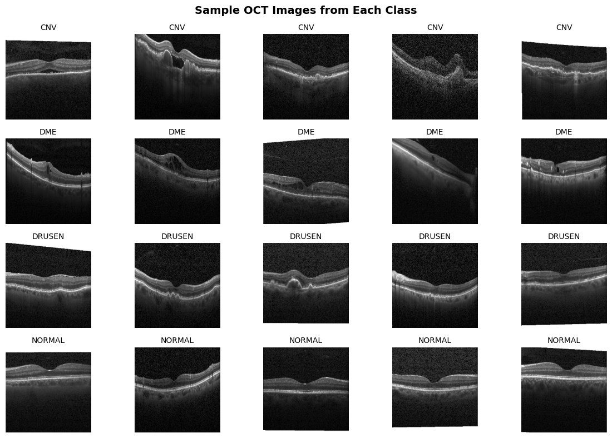
Fig 3: Class-wise samples of OCT images
- DATA PREPARATION AND PRE-PROCESSING
The steps that are implemented to prepare the OCT images for the model are: data loading, and data selection. Images were loaded in grayscale to reduce complexity and focus on the structural details that are relevant to retinal diseases. This step ensured uniform input channels for the model. To reduce computational load and ensure balanced representation of all classes, a batch size of 500 is considered.
Multiple preprocessing steps are also used to modify the data to make it suitable for model training. These include resizing, normalization, augmentation, and label encoding. All images were resized to 224x224 pixels to ensure uniform input dimensions for the InceptionV3 model. Pixel values are normalized by scaling them to the range [0,1]. Many data augmentation techniques were employed such as flipping, rotation and zooming. The four class labels are encoded using one-hot encoding.
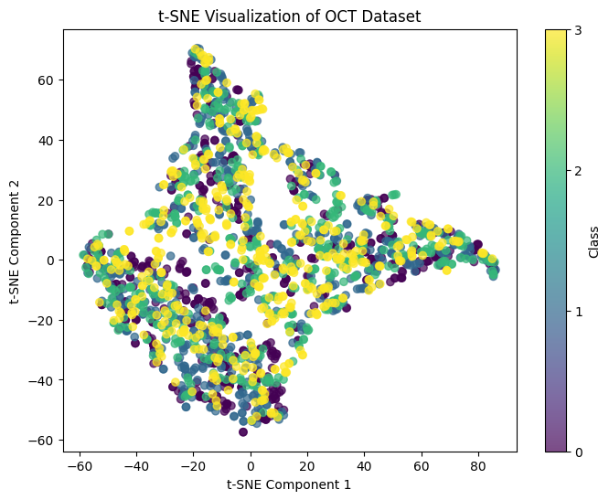
Fig. 4 depicts a scatter plot obtained by performing t-SNE (t-Distributed Stochastic Neighbour Embedding) on the training set. This method is widely used for visualizing high
Fig 4: t-SNE Scatter Plot
dimensional data before training. It helps to understand the structure of the dataset by reducing its dimensions while preserving local relationships between data points. The scatter plot obtained for this dataset is observed to have significant overlap between classes, implying high intra-class variance, making classification harder. Some colors appear more frequently than the rest, suggesting class imbalance. Some points scattered away from the main dense region, indicating noise or mislabeled data. It is also observed that there are no perfectly separated clusters, hinting that the features used may not provide a strong class distinction.
The class label mapping is as follows: CNV (0), DME (1), DRUSEN (2), NORMAL (3).
- MODEL ARCHITECTURE
The base-model used in this study is InceptionV3 with all its layers allowed to remain trainable. The pre-trained weights provide the foundation to which the model adapts and learns features during training on the OCT images. The final layers added to this model were Flatten and Dense layers. The former is used to convert multi-dimensional data into a 1D vector format. The latter is a fully connecting layer with 4 neurons- one for each class: CNV, DME, DRUSEN, and NORMAL. This layer uses the SoftMax activation function. To help with regularization and prevent overfitting, an EarlyStopping mechanism is applied. The layer-wise structure is as shown in Table 2.
Table 2 : Summary of InceptionV3-based Neural Network Architecture
Layer (type) | Output Shape | Number of parameters
inception_v3 (Functional) | (None, 5, 5, 2048) | 21802784
flatten (Flatten) | (None, 51200) | 0
dense (Dense) | `(None, 4) | 204804
Total parameters: 22,007,588
Trainable parameters: 204,804
Non-trainable parameters: 21,802,784
- EVALUATION METRICS
The various evaluation metrics used in this study are accuracy, precision, recall, area under the curve (AUC), receiver operating characteristic (ROC), and confusion matrix. Accuracy is an indicator of the model. It is used to measure how well the model correctly classified the samples from the test set across classes. Area under the curve is utilized to estimate the model's efficiency to differentiate between diseased and non-diseased retinal images. Precision is used to measure the ratio of true positive predictions to all predicted positive samples. It helps to reduce the occurrence of false positive predictions. Recall is used to assess the model’s ability to correctly predict all actual positive cases. This helps to reduce false negative predictions. Finally, a confusion matrix is generated that provides a detailed overview of the model’s predictions. It provides an idea of the class-wise performances and potential misclassifications.
- EXPERIMENTAL SETUP
All experiments were conducted on an NVIDIA RTX 3060 GPU with 16GB VRAM and an Intel Core i9 processor with Python version 3.11.9 and TensorFlow version 2.19.0. The InceptionV3 model is employed with pre-trained ImageNet weights, and EarlyStopping is implemented with the patience of 5 epochs for better results. The dataset is divided in the ratio 7:2:1 into train, test and validation for each of the four classes: CNV, DME, DRUSEN and NORMAL.

RESULTS AND DISCUSSION
The model was trained using the InceptionV3 architecture to classify retinal diseases into 4 categories. The model’s performance was evaluated using accuracy, loss, F1-score, confusion matrix, and ROC-AUC curves. The model was monitored using early stopping, which stopped the model training after 10 epochs out of the originally planned 30 epochs. The final performance at the end of 10 epochs and on the test dataset is as follows:
Table 3: Model Performance

Performance Metrics | Training | Validation | Testing
Loss | 0.2035 | 0.3934 | 0.3250
Accuracy | 0.9297 | 0.8828 | 0.8967
Area under curve | 0.9915 | 0.9759 | 0.9819
Precision | 0.9326 | 0.8883 | 0.9014
Recall | 0.9273 | 0.8791 | 0.8920
By evaluating the performance metrics we can judge how effectively the model works. The model performed well across training, validation and testing as seen in Table 3. Training, validation and testing losses were 0.2035,0.3934 and 0.3250, respectively. The slight increase in validation loss corresponds to some degree of overfitting though the lower test loss suggests that the model generalizes well. In terms of accuracy, the model achieved 92.97% on the training set, with a slight drop to 88.28% on validation and 89.67% on the test, all indicating good performance. The AUC values remained consistently high throughout all phases: 0.9915 during training, 0.9759 during validation, and 0.9819 during testing. This demonstrates the model’s ability to distinguish between the four classes.The precision scores for training, validation, and testing were 93.26%, 88.83%, and 90.14%, respectively, while the recall scores were 92.73%, 87.91%, and 89.20%. These results indicate reliable classification performance with a low occurrence of false positives and false negatives.
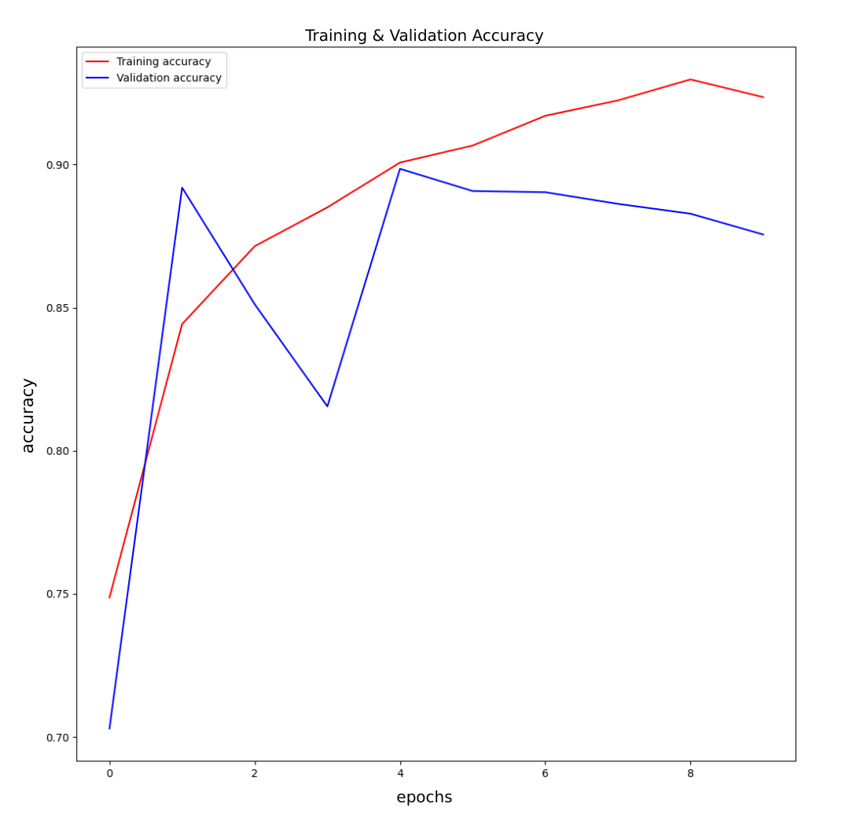
Fig 5: Training and Validation Accuracy
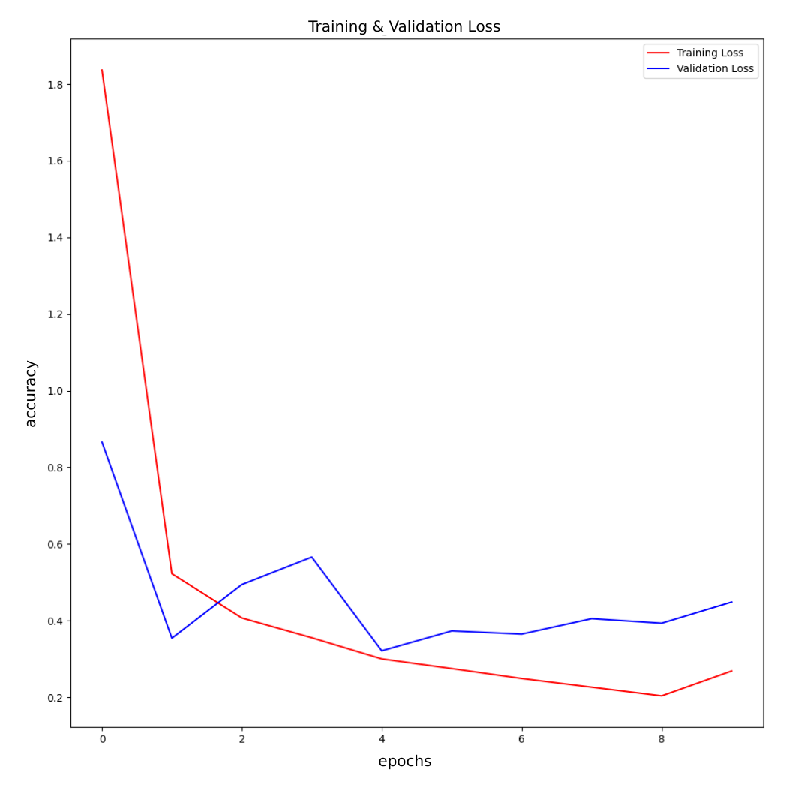
Fig 6: Training and Validation Loss
Fig. 5 depicts the training and validation accuracy plot. It shows a steady increase in training accuracy, approaching 0.92, while validation accuracy fluctuates slightly after an initial increase, settling at a slightly lower value. Fig. 6 depicts the training and validation loss plot. It is observed to follow a similar pattern, with training loss decreasing consistently and validation loss stabilizing with minor fluctuations. Since early stopping was used, training likely stopped at an optimal point to maintain a balance between learning and generalization. Although there is a small gap between training and validation performance, the model performs effectively on the dataset. Overall, the model learned effectively during training, achieving high classification performance with a low error rate. While the model exhibits mild overfitting, the test performance remains robust.
To evaluate class-wise performance, F1-score was calculated, and a confusion matrix was generated.
Table 4: Classification Report
 | Precision | Recall | F1-score | Support
CNV | 0.93 | 0.92 | 0.93 | 3746
DME | 0.81 | 0.82 | 0.82 | 1161
DRUSEN | 0.59 | 0.65 | 0.62 | 887
NORMAL | 0.95 | 0.94 | 0.94 | 5139
Table 4 outlines the classification report, demonstrating strong model performance for CNV and NORMAL cases, with F1-scores of 0.93 and 0.94, respectively, indicating high precision and recall. DME classification also performs well (F1-score: 0.82), though slightly lower than CNV and NORMAL. DRUSEN classification is weaker (F1-score: 0.62), suggesting difficulty in distinguishing this class, likely due to class imbalance and feature similarities with other conditions.
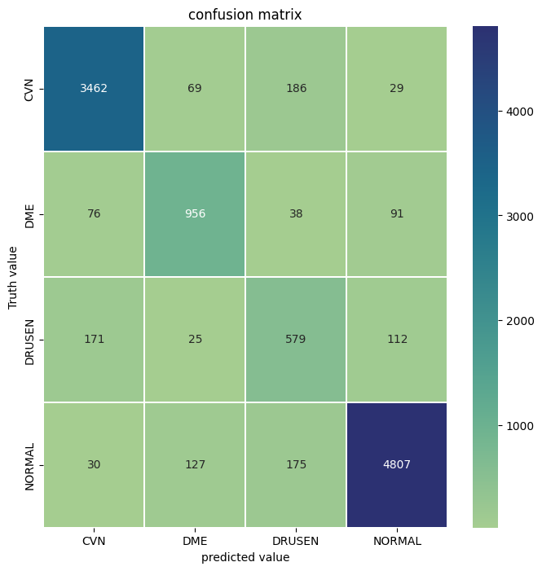
Fig 7: Confusion Matrix
The confusion matrix, as observed in Fig. 7, shows strong classification performance for CNV and NORMAL (3462 and 4807 correct predictions, respectively). DME is also well-identified with 956 correct predictions. DRUSEN exhibits significant misclassification, particularly with CNV (171 cases) and NORMAL (112 cases), which correlates with its lower F1-score. The model correctly predicts 90.3% CNV cases. DME is predicted 79.1% correctly out of all cases. It is misclassified with NORMAL (7.5%) and CNV (6.3%). DRUSEN shows the lowest classification accuracy of 64.7%, which suggests that the model found it challenging to distinguish. NORMAL class had the highest accuracy with 93.2% accurately classified images. These results highlight the need for further refinements, such as feature enhancement or class-balancing strategies, to improve DRUSEN classification.

COMPARATIVE STUDY
Table 5: Results of replicative study
Testing Performance Metrics | Kermany et al. | This study
Accuracy | 0.9660 | 0.8967
Area under curve | 0.9990 | 0.9819
Recall | 0.9780 | 0.8920
From table 5, it is evident that Kermany et al. developed a superior model and obtained a higher accuracy, AUC, and recall values.
Potential causes of these deviations in this study’s results may be due to:
- Excessive fine-tuning or high learning rate
- Lack of precomputed bottlenecks for speed
- Patient-wise splitting strategy to prevent leakage
- Batch size and epoch: 100 epochs with 1,000 images per step
Due to RAM limitations during training, the batch size was reduced from 512 to 256. While this allowed for smoother training within hardware constraints, it might have influenced the model's convergence behavior and generalization performance.

FUTURE WORKS AND IMPROVEMENTS
Checking for misclassification can be done by analyzing the confusion matrix to see which classes are often confused. Recall for critical cases can be improved by data augmentation or class balancing. Fine tuning the model by hyperparameter tuning or adding attention mechanisms may further improve performance. Post training enhancements such as model ensembling and test-time augmentations may be incorporated.

REFERENCES
- Age-related macular degeneration. (2020). Genetics and Genomics of Eye Disease, 155–180. https://doi.org/10.1016/B978-0-12-816222-4.00010-1
- Johns Hopkins Medicine. (2019). Age-Related macular degeneration (AMD). Johns Hopkins Medicine. https://www.hopkinsmedicine.org/health/conditions-and-diseases/agerelated-macular-degeneration-amd
- Spalton, D. J., Hitchings, R. A., & Hunter, P. (2013). Atlas of Clinical Ophthalmology E-Book. Elsevier Health Sciences.
- Hobbs, S. D., & Pierce, K. (2021). Wet Age-related Macular Degeneration (Wet AMD). PubMed; StatPearls Publishing. https://www.ncbi.nlm.nih.gov/books/NBK572147/
- Marieta Dumitrache. (2024). Ophthalmological Pathology and Management in Eye Disease: non Age Related Macular Degeneration (AMD) Pathology. Clinical Ophthalmology, 463–486. https://doi.org/10.1007/978-3-031-68453-1_16
- Parsa Riazi Esfahani, Reddy, A. J., Neel Nawathey, Ghauri, M. S., Min, M., Wagh, H., Tak, N., & Patel, R. (2023). Deep Learning Classification of Drusen, Choroidal Neovascularization, and Diabetic Macular Edema in Optical Coherence Tomography (OCT) Images. Cureus. https://doi.org/10.7759/cureus.41615
- Varma, R., Bressler, N. M., Doan, Q. V., Gleeson, M., Danese, M., Bower, J. K., Selvin, E., Dolan, C., Fine, J., Colman, S., & Turpcu, A. (2014). Prevalence of and Risk Factors for Diabetic Macular Edema in the United States. JAMA Ophthalmology, 132(11), 1334–1340. https://doi.org/10.1001/jamaophthalmol.2014.2854
- Aumann, S., Donner, S., Fischer, J., & Müller, F. (2019). Optical Coherence Tomography (OCT): Principle and Technical Realization. High Resolution Imaging in Microscopy and Ophthalmology, 59–85. https://doi.org/10.1007/978-3-030-16638-0_3
- OCT Principle. (2023). Santec OIS. https://ois.santec.com/oct-principle
- Weiss, K., Khoshgoftaar, T. M., & Wang, D. (2016). A survey of transfer learning. Journal of Big Data, 3(1). https://doi.org/10.1186/s40537-016-0043-6
- Turbert, D. (2023, April 27). What Is Optical Coherence Tomography? American Academy of Ophthalmology. https://www.aao.org/eye-health/treatments/what-is-optical-coherence-tomography
- Muhammed Halil Akpinar, Abdulkadir Sengur, Faust, O., Tong, L., Molinari, F., & U. Rajendra Acharya. (2024). Artificial Intelligence in Retinal Screening Using OCT Images: A Review of the Last Decade (2013-2023). Computer Methods and Programs in Biomedicine, 254, 108253–108253. https://doi.org/10.1016/j.cmpb.2024.108253
- Jain, L., Murthy, H. S., Patel, C., & Bansal, D. (2018, December). Retinal eye disease detection using deep learning. In 2018 Fourteenth International Conference on Information Processing (ICINPRO) (pp. 1-6). IEEE.
- Rajagopalan, N., N, V., Josephraj, A. N., & E, S. (2021). Diagnosis of retinal disorders from Optical Coherence Tomography images using CNN. PloS one, 16(7), e0254180.
- Viedma, I. A., Alonso-Caneiro, D., Read, S. A., & Collins, M. J. (2022). Deep learning in retinal optical coherence tomography (OCT): A comprehensive survey. Neurocomputing, 507, 247-264.
- Özdaş, M. B., Uysal, F., & Hardalaç, F. (2023). Classification of Retinal Diseases in Optical Coherence Tomography Images Using Artificial Intelligence and Firefly Algorithm. Diagnostics (Basel, Switzerland), 13(3), 433. https://doi.org/10.3390/diagnostics13030433
- Baba, S., Kumari, P., & Saxena, P. (2024). Retinal Disease Classification Using Custom CNN Model From OCT Images. Procedia Computer Science, 235, 3142-3152.
- Leandro, I., Lorenzo, B., Aleksandar, M., Dario, M., Rosa, G., Agostino, A., & Daniele, T. (2023). OCT-based deep-learning models for the identification of retinal key signs. Scientific Reports, 13(1), 14628.
- Kermany, D. S., Goldbaum, M., Cai, W., Valentim, C. C., Liang, H., Baxter, S. L., ... & Zhang, K. (2018). Identifying medical diagnoses and treatable diseases by image-based deep learning. cell, 172(5), 1122-1131.
- Alkhawaldeh, I. M., Albalkhi, I., & Naswhan, A. J. (2023). Challenges and limitations of synthetic minority oversampling techniques in machine learning. World journal of methodology, 13(5), 373.

